**P4 – Design web pages using CSS to control layout**

**Introduction**

**User Requirements**

**Pages**

1. Home
2. News
3. Transfer Centre
4. Contact Us

**Features**

* The features would be to add more colour to each of the page. I also added a search bar to the home page so the user can search anything from the search button.

**Background**

The background will be different colour for each page. For example, the home page would be blue.

**Main Body Text**

Depending on each page, the main body text will be roughly the same.

**Headings**

The Headings would use Calibri and the size of the text would be around 16. Each page would be relevant and the heading would be the same.

**Images**

The images will be relevant to the topic that is discussed within the page. For example, if the topic is about Gerrard’s career, the page would have pictures of Gerrard winning the Champions League.

**Links**

Each page will be linked with each other. If any user wants to visit the home page, all they need to do is click the home page.

**Layout**

The first home page would contain information about the website and the latest information on football. The Transfer Centre would contain information about the latest transfer news going around the world. Lastly, the news would contain latest football scores and more.

**Contact Us Information**

Contact us information is very useful. Users, who have concerns, would visit the contact page if they have any concern on the website.

**Navigation Diagram**

Home page

**Starts from the home page**

News

Contact Us

Transfer Centre

**Design**

**Home Page**

**BANNER**

MENU BAR

LATEST NEWS

ARSENAL WIN CHAMPIONS LEAGUE

ARSENAL WIN RACE FOR JACKSON MARTINEZ

MESSI ON TRIAL

MAN UNITED WIN FA CUP

**FOOTER**

**Design**

**Transfer News**

**BANNER**

MENU BAR

TRANSFER NEWS

ARSENAL MAKE MOVE FOR JACKSON MARTINEZ

LIVERPOOL SIGN PER MERTERSACKER

**FOOTER**

**Design**

**News**

**BANNER**

MENU BAR

TRANSFER NEWS

ARSENAL WIN THE CHAMPIONS LEAGUE

LIVERPOOL RELEGATED

**FOOTER**

**Design**

**Contact Us**

**BANNER**

MENU BAR

MESSAGE

EMAIL

NAME

SUBMIT

**FOOTER**

**P5 – Create interactive web pages using CSS and a scripting language & M3 – Employ good practice in the design and implementation of web pages**

**Introduction**

In this report, I will access each page using CSS and scripting language whilst employing good implementation of web pages. I will also test it too.

**Home Page**

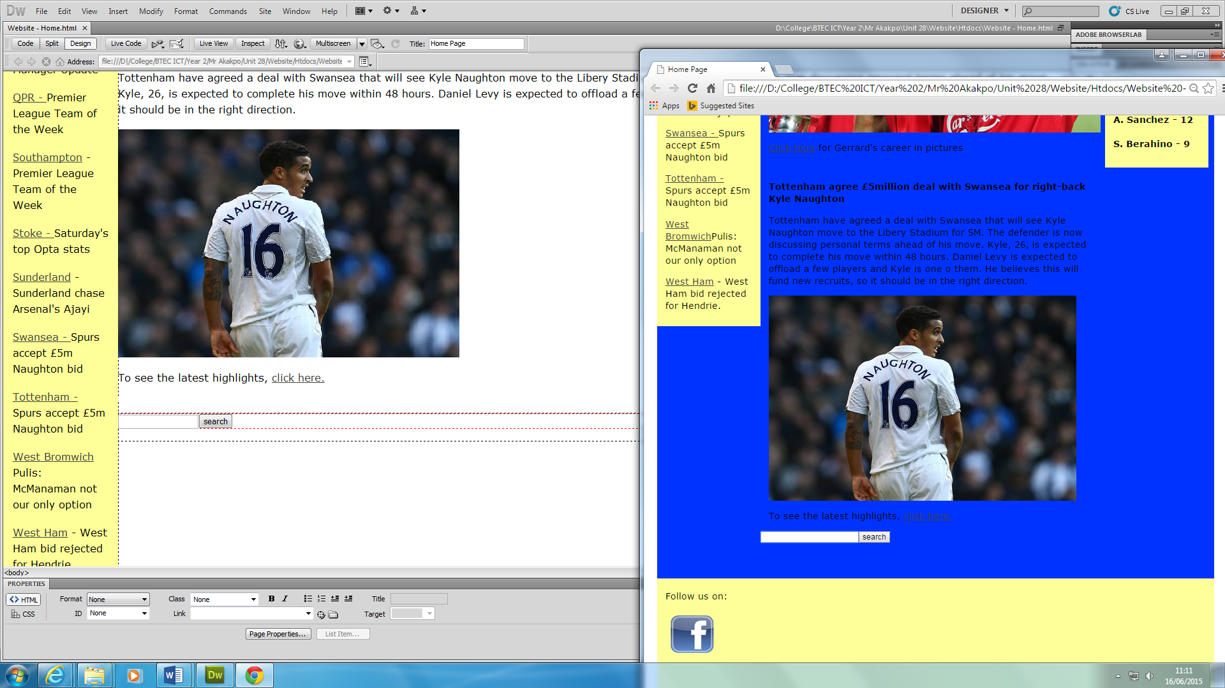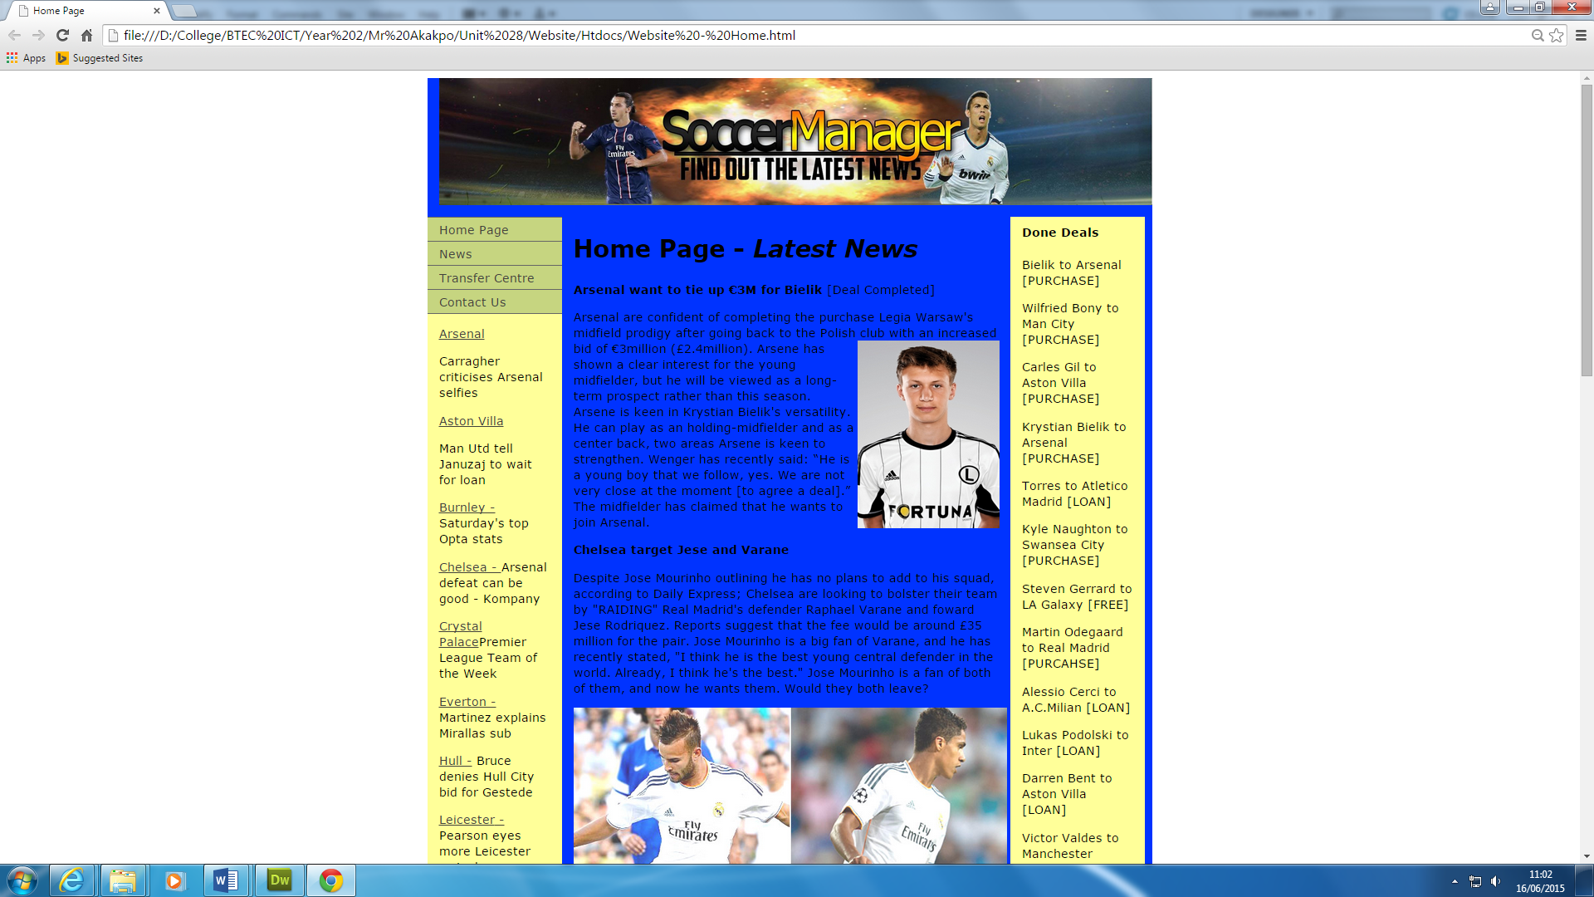

This is the home page. As you can see, the colour of it is blue as planned. The other colours have changed too. The menu bar is on the top-right hand side. You can change the page by using the navigation bar. There is a search button for the user to search anything too.

**HTML and HyperLinks**

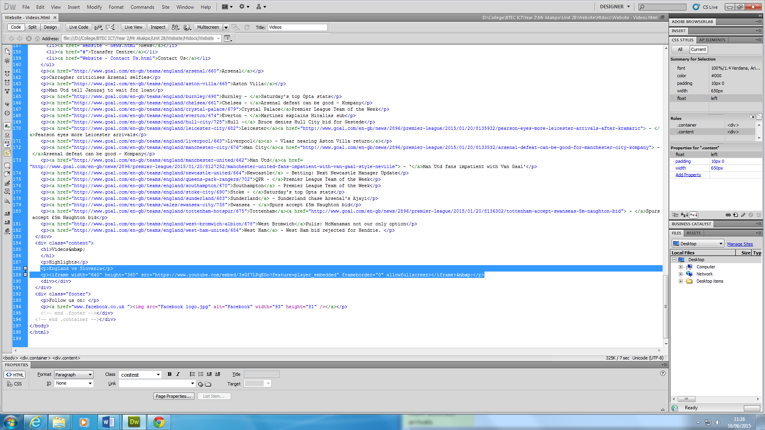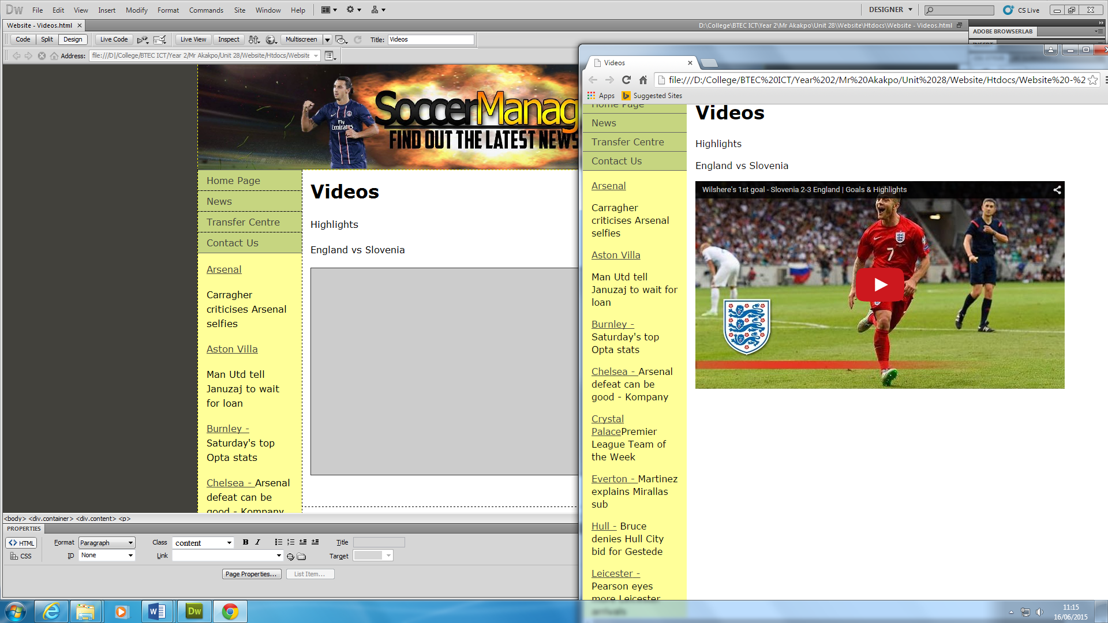

This is the YouTube link that is linked. Both screenshots show how the YouTube link is set out. First of all, you copy the embedded code onto the link so that it can work whilst pasting it. Pasting it can enable the video to work.

**JavaScript**

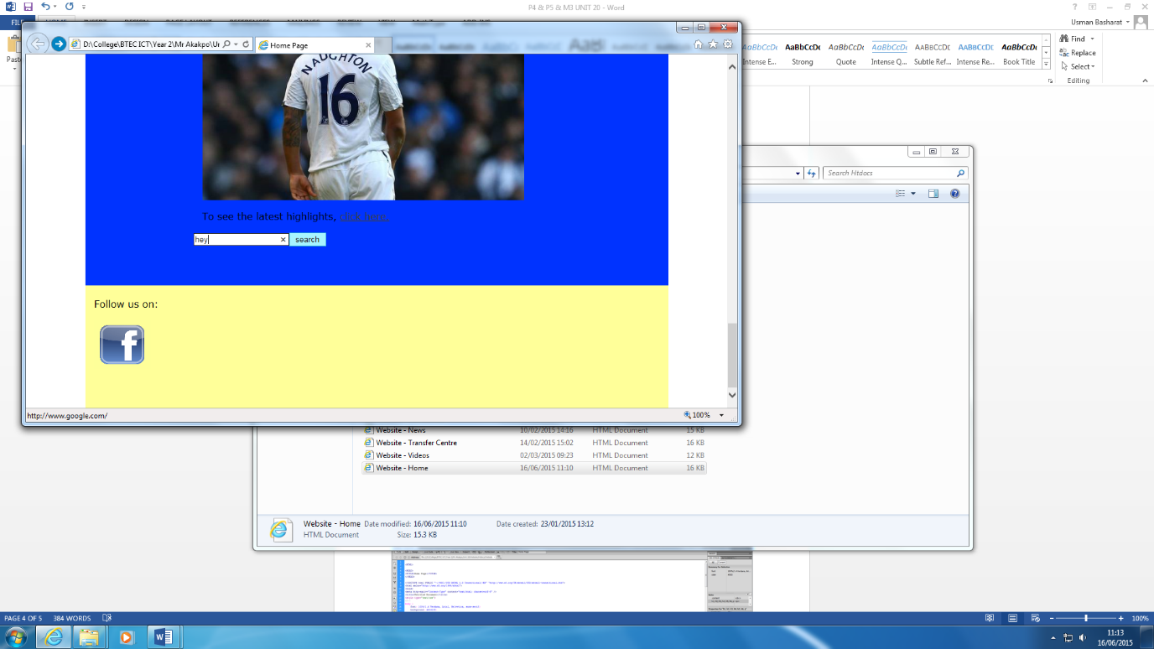

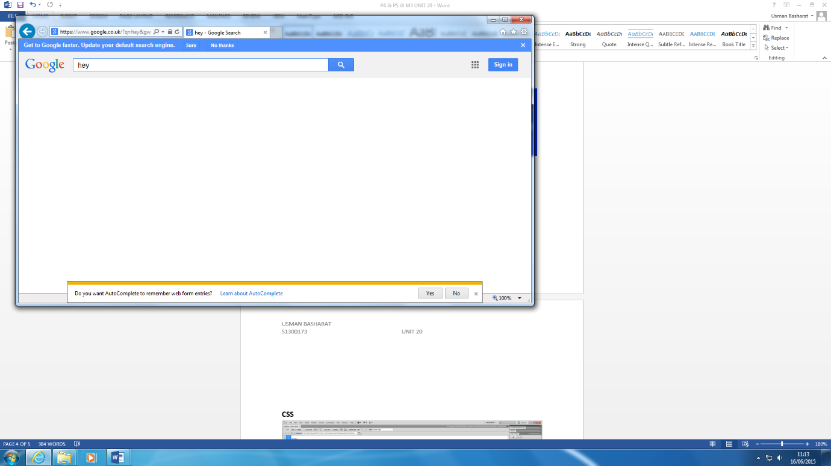

This is the search bar that the user can search anything on the website. As you can see, I typed in what I needed to search and the search bar enabled me to search it into to [www.google.co.uk](http://www.google.co.uk). This is very useful.

**CSS**

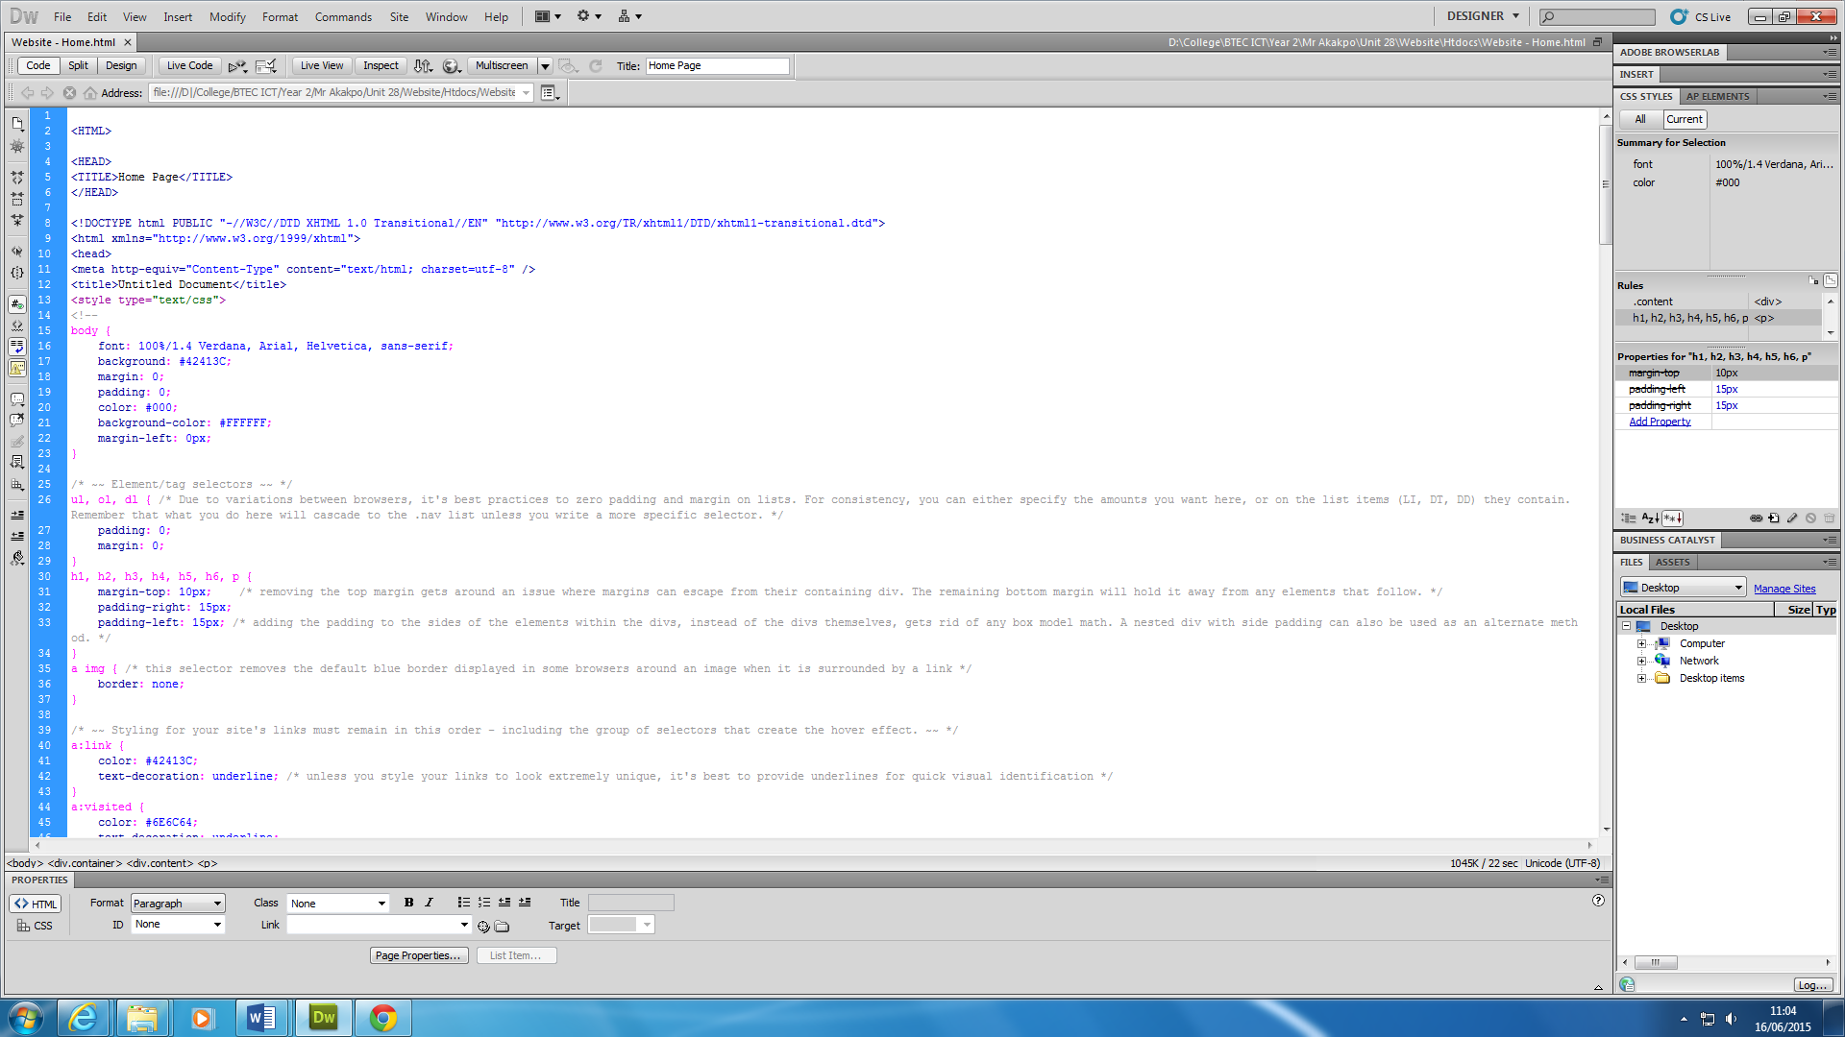

This is the CSS shown on the screenshot.

As you can see, the box model has been implemented within the CSS coding with the font too.

**Editing**

**Margin, padding, content**

**P6 – Test interactive web pages**

**Test**

|  |  |  |  |  |  |
| --- | --- | --- | --- | --- | --- |
| **Test number** | **Feature tested** | **Expected result** | **Actual result & comments** | **Pass or fail** | **Screenshot reference** |
| 1. | Search Bar | I expect the search bar to link it to [www.google.co.uk](http://www.google.co.uk) and the search information to search. | The actual result tested worked. | Pass | Figure 1.1 |
| 2. | Links | I expect the navigation bar to link with the other pages. | The links set out worked. | Pass | Figure 1.2 |
| 3. | Video | I expect the video to play. | The video started to play. | Pass | Figure 1.3 |
| 4. | Background | I expect the background to be implemented on to the page | The blue background was implemented onto the page. | Pass | Figure 1.1 |
| 5. | Links on Picture | I expect the link to go to the expected link. | The link went to Facebook. | Pass | Figure 1.4 |
| 6. | Heading | To see if the heading is implemented and the same on each page. | The heading was the same on the pages. | Pass | Figure 1.5 |
| 7. | Gallery | I expect the links to work and gallery to appear | The gallery appeared with the pictures too. | Pass | Figure 1.6 |



**Figure 1.1**





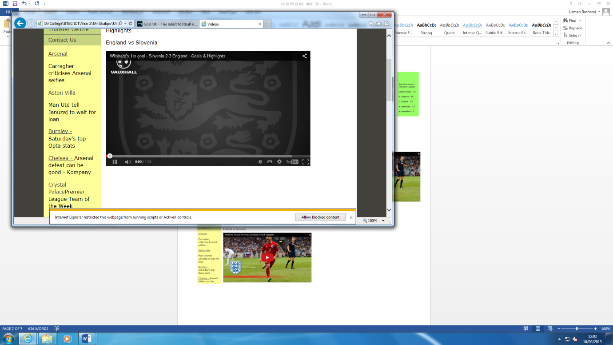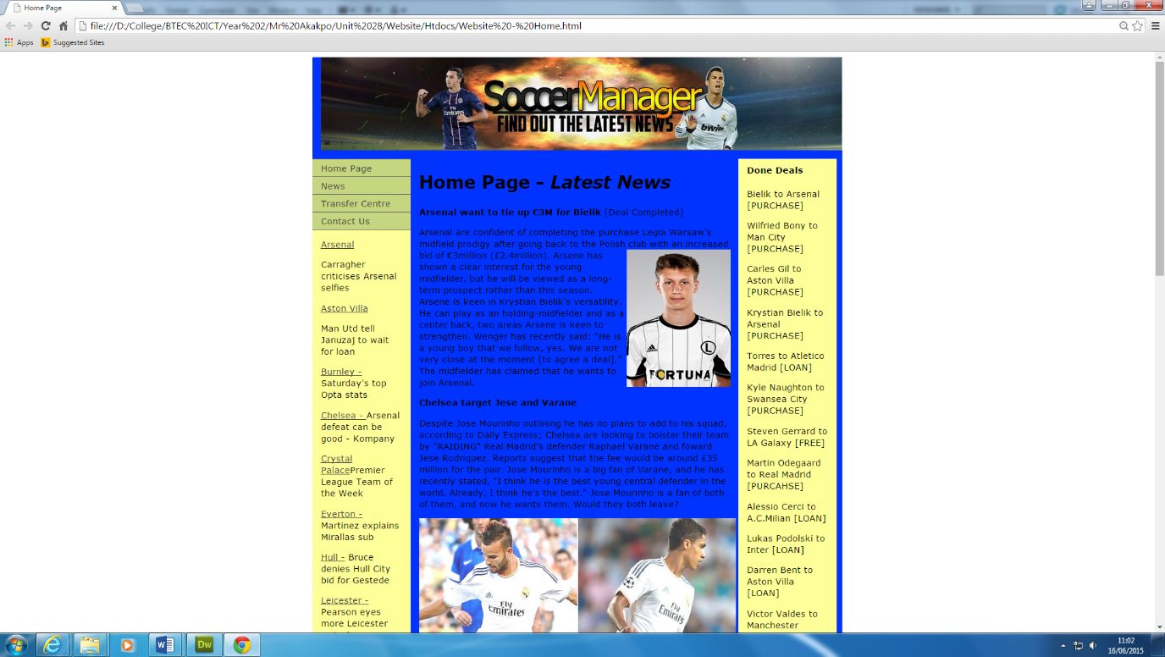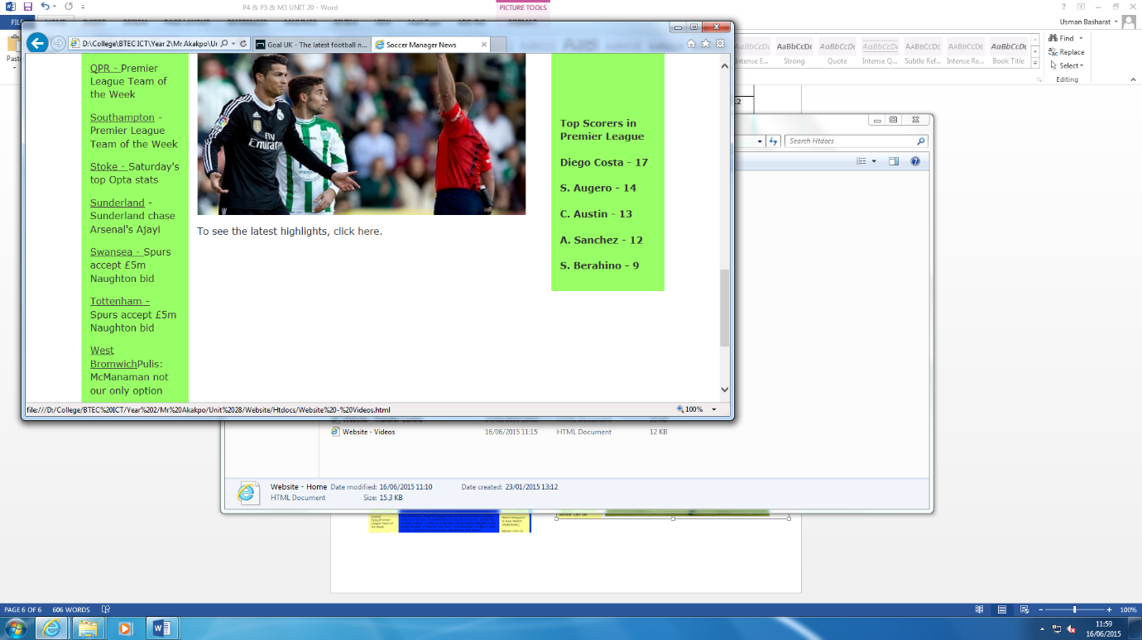

**Figure 1.3**

**Figure 1.2**

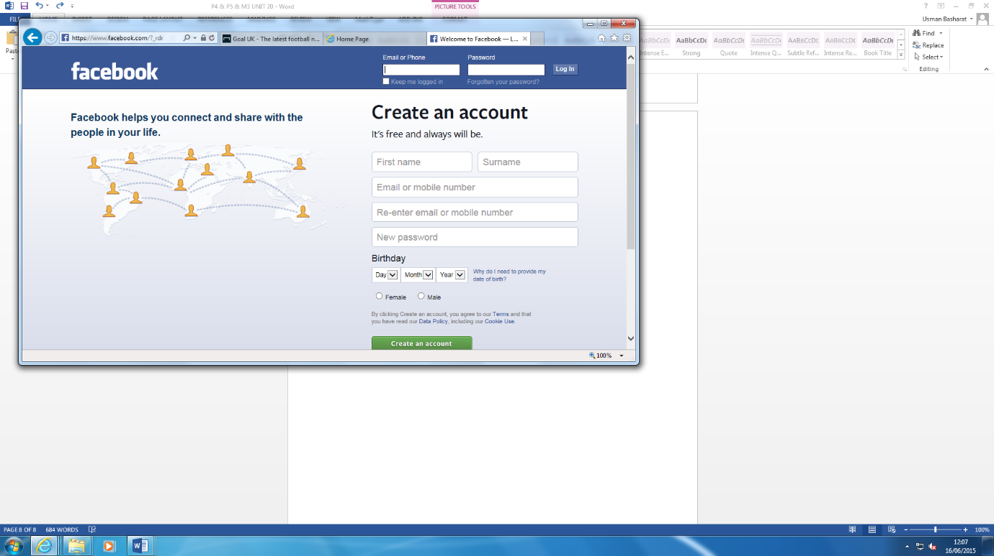

**Figure 1.4**



**Figure 1.5**



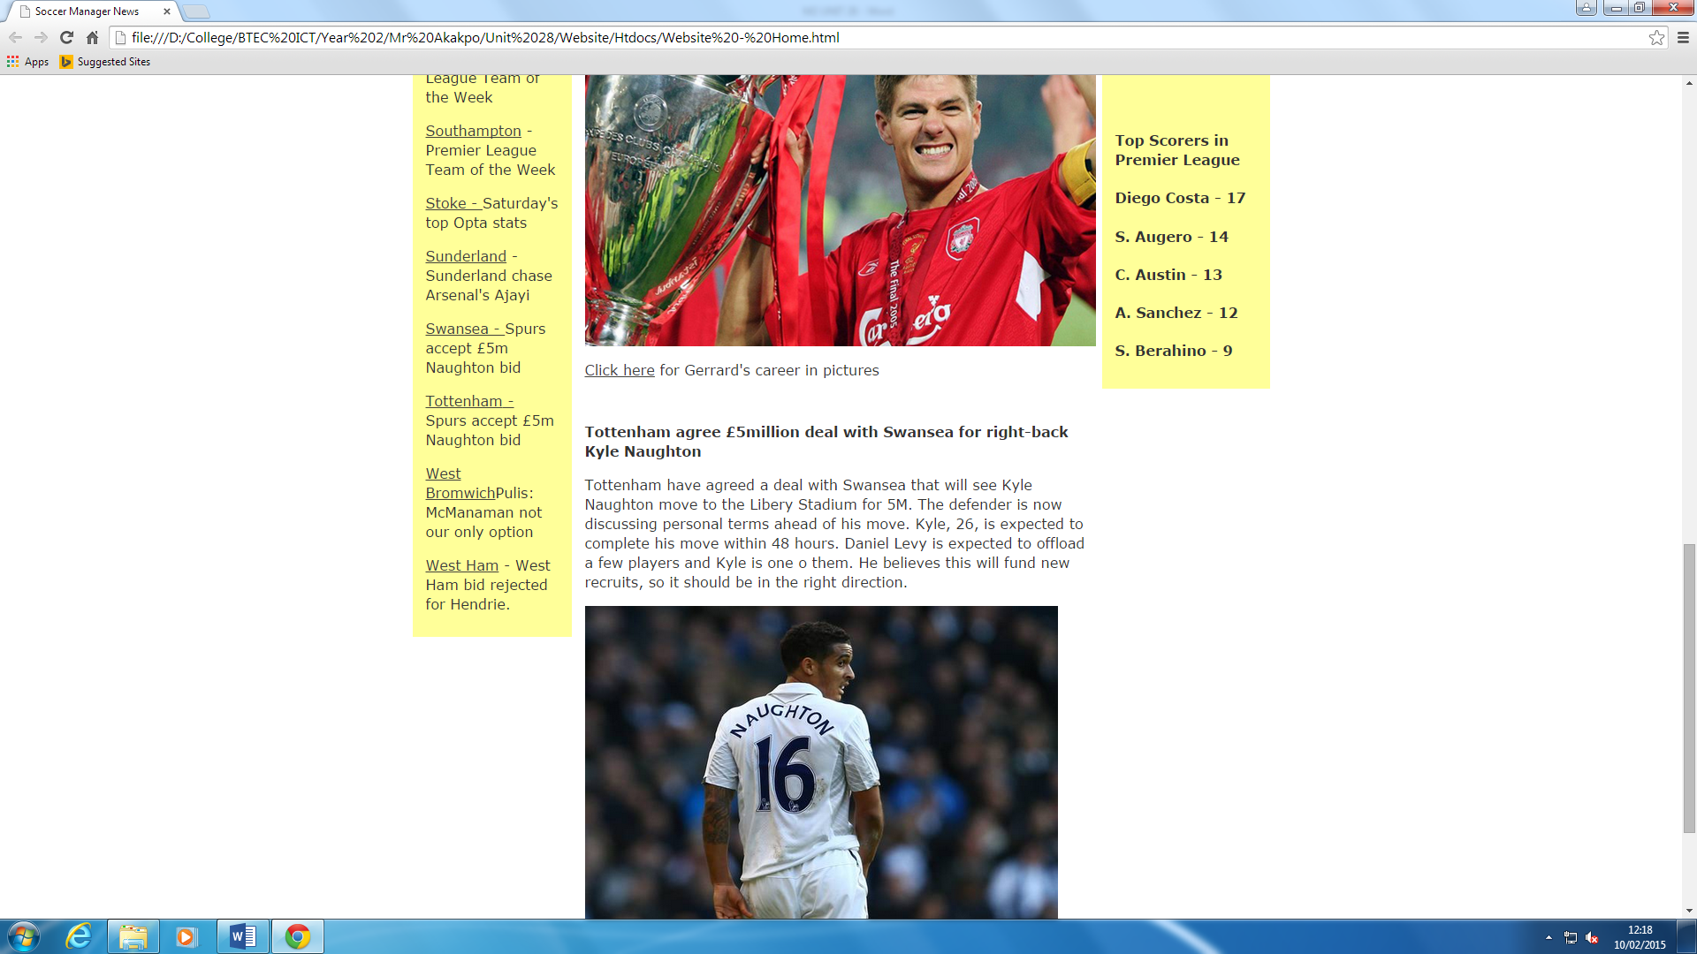

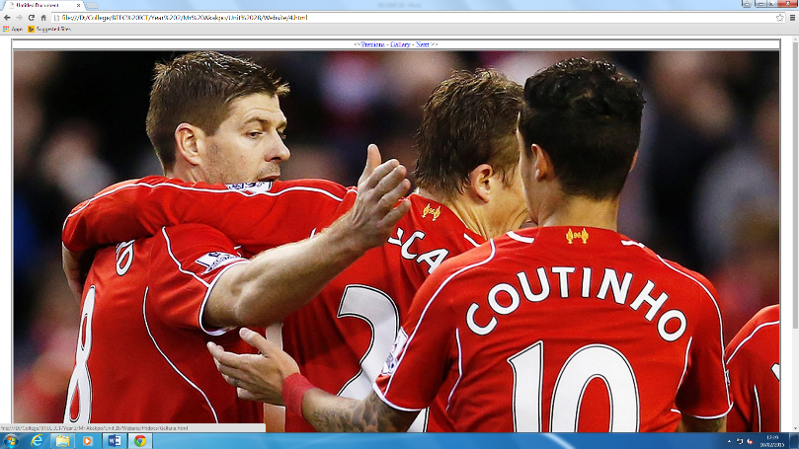

**Figure 1.6**

